# Prog 117 – Class Project (30% of your final grade)

For the final project of the class we will be creating a DVD web site that allows customer to browser and purchase DVDs as well as allows Admins to create, edit and delete the DVDs in the collection.

For the database portion of this project, use the Dvd117Database.sql script provided on Canvas to populate your database. Make sure it is named Dvd117 when you create it in Management Studio.

The DVD project is going to be very similar to DorkNozzle in structure and functionality. We will be using a project with Master Pages to provide common framework for hosting the pages in our project, as can be seen an example Home Page below:

**Master Page**

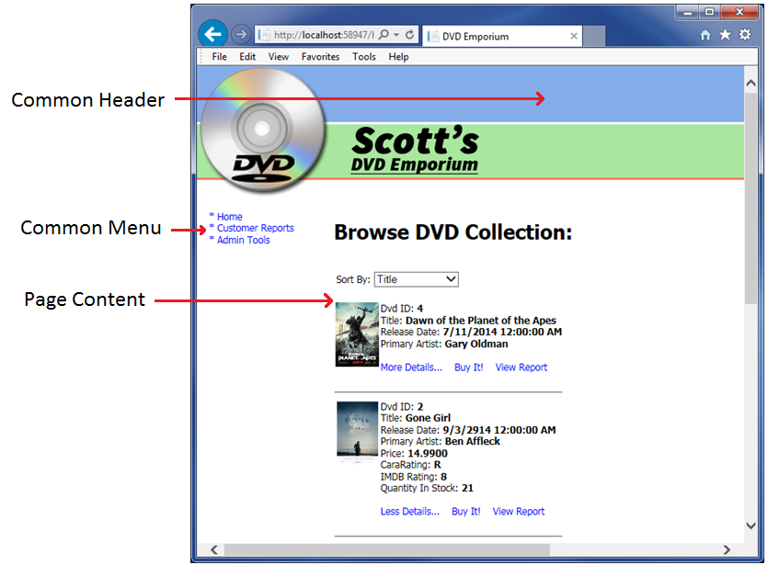

## Project Scope

All total there will be 7 pages necessary to complete this project, in addition to the Site.Master template, a DVDStyles.css style sheet, a Web.sitemap navigation file and of course the Web.config. These 7 pages are (we will discuss each in detail a little later):

1. Home Page
2. Purchase DVD Page
3. Thank You for your purchase Page
4. DVD Report Page
5. Customer Report Page
6. Login Page
7. AdminTools Page

To the extent that you want to use graphics and images to make your DVD site look better, that is up to you. At a minimum you must have a Master page banner image that sits at the top and you must use the coverImageUrls provided for the DVDs.

Now let’s look at each page individually and enumerate the important aspects of each page.

## Home Page

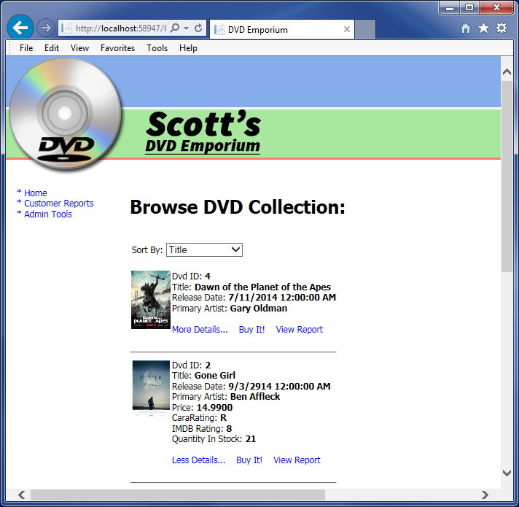

**Important Features of the Home Page:**

* Displays a list of all the DVDs in the collection
* Allows the user to sort the list by Title, Artist and Release Date
* Displays basic set of details along with an image of the DVD cover
* More details button allows you to see addition fields (Price, CaraRating, IMDBRating and QuantityInStock).
* Upon expanding, More Details turns into Less Details. When clicked, Less Details returns us back to the original state of just the basic fields
* The BuyIt! Button allows us to buy the DVD by navigating to the purchase dvd page.
* The View Report button takes us to a DVD report page that shows us a report for that particular DVD.

**Important Problems to Solve:**

* Sorting of the DVD list
* More Details shows many fields, not just one as DorkNozzle did
* Less Details is something new that DorkNozzle did not do, how can we accomplish this?
* Buy It redirects to purchase page but we will need to pass in which DVD to buy. How can we do that? Session State? Passing a parameter in the URL?
* View Report has the same issue of redirecting and needing to pass the DVDId.

## Purchase DVD Page

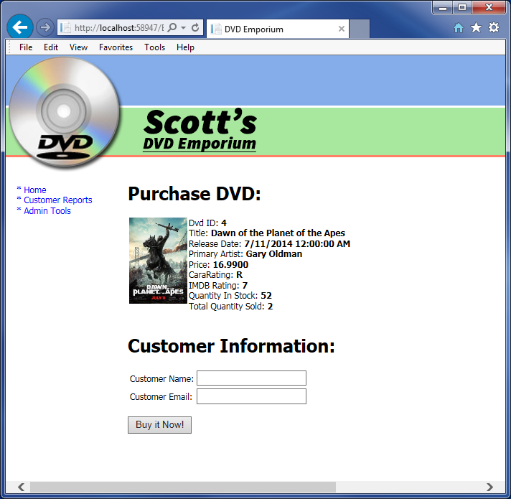

**Important Features of the Home Page:**

* Displays all the details of the requested DVD
* Allows the user to enter in their customer information (we’ll need Validation!)
* Buy It Now button causes the DVD to be purchased (the Database has a spPurchaseDvd stored procedure that handles the actual DB work.)

**Important Problems to Solve:**

* How does this page know which DVD to present to the user? Can I pass a DVDId in as a parameter to this page somehow?
* We’ll need to get and display the info for just 1 DVD? Can we reuse code from the HomePage DataList to do this?
* How do I validate Email Address? XXXX@YYY.COM??
* <asp:RegularExpressionValidator ID="regexEmailValid" runat="server" ValidationExpression="\w+([-+.]\w+)*@\w+([-.]\w+)*\.\w+([-.]\w+)*" ControlToValidate="tbEmail" ErrorMessage="Invalid Email Format"></asp:RegularExpressionValidator>
* Any script tags posted on an ASP.NET web form will cause your site to throw and unhandled exception.
* You can use a asp regex validator to confirm input, just ensure you wrap your code behind method with a if(IsValid) clause in case your javascript is bypassed. If your client javascript is bypassed and script tags are posted to your asp.net form, asp.net will throw a unhandled exception.

## DVD Report

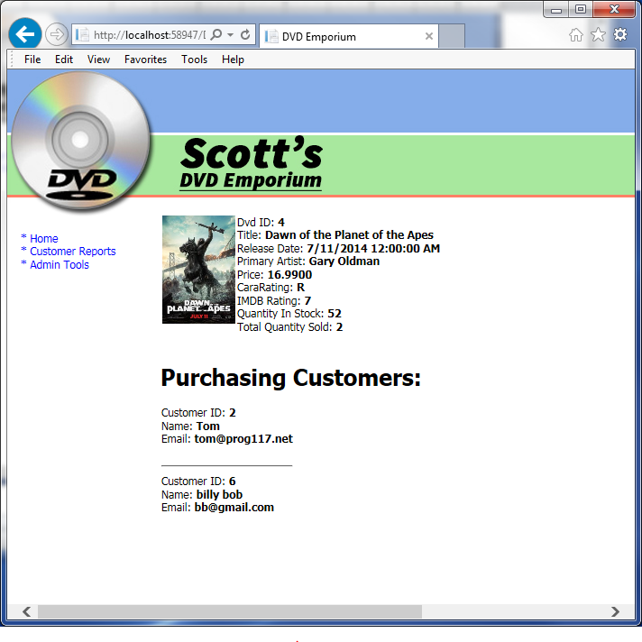

**Important Features of the Home Page:**

* Displays all the details of the requested DVD
* Shows all the customers who purchased the DVD

**Important Problems to Solve:**

* How does this page know which DVD to present to the user? Can I pass a DVDId in as a parameter to this page somehow?
* We’ll need to get and display the info for just 1 DVD? Can we reuse code from the PurchasePage to do this?

## Customer Report

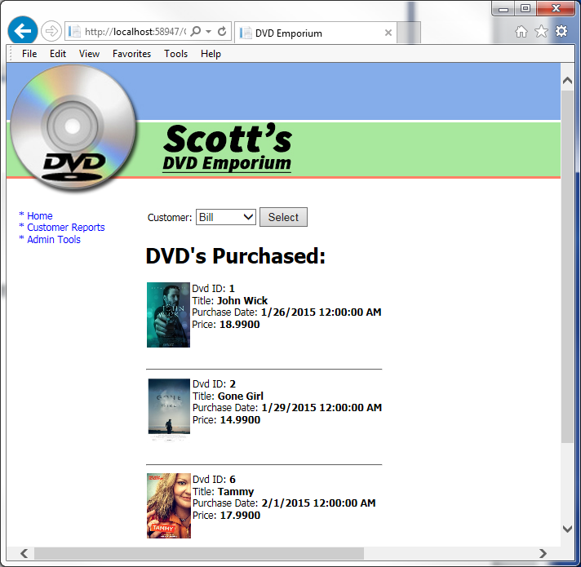

**Important Features of the Home Page:**

* Displays all the customers in a DropDownList and allows user to select one
* When SELECT button is clicked, displays a list of all the DVDs the selected customer has purchased and for how much

**Important Problems to Solve:**

* The info in the DVD list comes from 2 different tables. How am I go to create a query to do this?

## Login

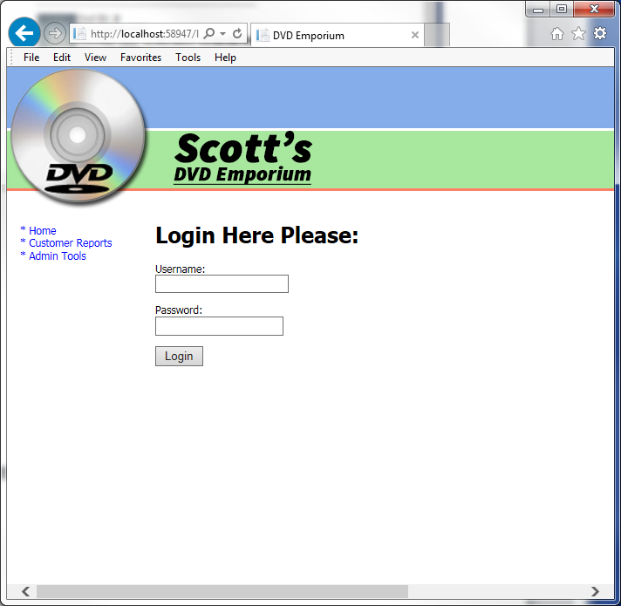

**Important Features of the Home Page:**

* Shows up when attempting to access the Admin Tools page if the user is not already logged in
* Does NOT show up if the user is already logged in.
* Validates the username and password fields
* Logs the user in when the button is clicked

**Important Problems to Solve:**

* How do I get this page to show up at the right time and not show up any time else?
* How do I log the user in?
* How do I redirect to the originally requested page?

## Admin Tools

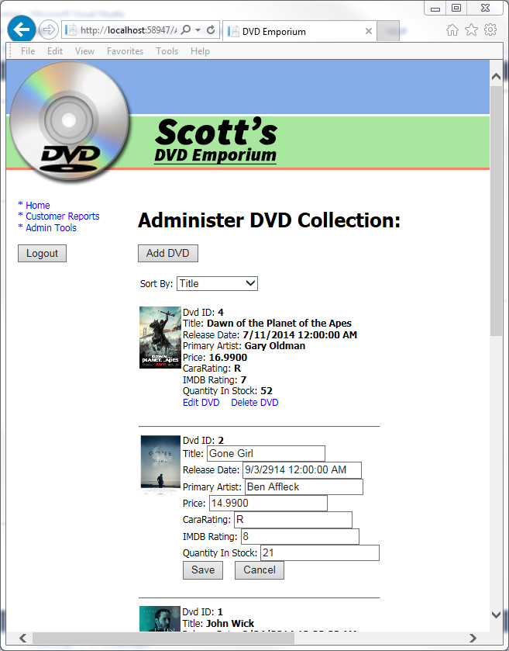

**Important Features of the Home Page:**

* Shows a list of all the DVDs
* Allows the Admin to sort this list by Title, Artist or Release Date
* Allows the Admin to Delete a DVD if they want
* Allows the Admin to Edit a DVD (see the second DVD in the list for what this looks like)
* Allows the user to Save and/or cancel an editing session
* Allows the Admin to Add a new DVD (see screen shot below for what this looks like)
* Allows the Admin to Save/Cancel an Add New DVD session

**Important Problems to Solve:**

* How do I delete a DVD from the database and then cause my list to refresh?
* How do I enter into Editing mode for a single DVD?
* How do I validate all those fields in the editing mode?
* How do I save changes to DB?
* How do I throw changes away when cancel is hit?
* When Add New DVD is clicked, how do I hide the DropDownList and DataList so I can show my Add New DVD controls?
* How do I INSERT a new DVD when Save is clicked?
* How do I go back to my original state when Cancel is clicked?

### Adding a new DVD



Below is the scoring breakdown for this project. Please read through this carefully and make sure you understand each of the items as it pertains to each page.

## Scoring Rubric (Total of 200 points)

20 pts – Master Page – Site.Master

|  |  |
| --- | --- |
| 5 pts | Does it display a relevant header across the top of the page? |
| 5 pts | Does it display the menu from Web.sitemap correctly? |
| 5 pts | Does it handle the LOGOUT button correctly when clicked? |
| 2 pts | Does it pull in the Style Sheet correctly |
| 3 pts | Overall code quality (naming of variables, avoiding code duplication, etc…) |

30 pts - Home Page

|  |  |
| --- | --- |
| 5 pts | Does the Sort DropDownList work properly? |
| 5 pts | Does it sort? |
| 5 pts | Does it display the correct properties in the data list? |
| 3 pts | Does it display the correct properties in More Details? |
| 3 pts | Does Less Details hide those properties? |
| 2 pts | Does the Buy Button take you to the buy page correctly? |
| 2 pts | Does the Report Button take you to the report page correctly? |
| 2 pts | Are post backs handled correctly? |
| 3 pts | Overall code quality (naming of variables, avoiding code duplication, etc…) |

25 pts – Purchase DVD Page

|  |  |
| --- | --- |
| 5 pts | Does it receive the right DVDId correctly (however you decide to pass it)? |
| 5 pts | Does it display the correct DVD summary information |
| 5 pts | Does it collect and VALIDATE the correct customer information |
| 3 pts | Does it actually purchase the DVD and store the record in SQL? |
| 2 pts | Does it redirect you to the Thank You page correctly? |
| 2 pts | Are post backs handled correctly? |
| 3 pts | Overall code quality (naming of variables, avoiding code duplication, etc…) |

5 pts – Thank You Page

|  |  |
| --- | --- |
| 5 pts | Does it thank you and give you a link to continue shopping? |

20 pts –DVD Report Page

|  |  |
| --- | --- |
| 5 pts | Does it receive the right DVDId correctly (however you decide to pass it)? |
| 5 pts | Does it display the correct DVD summary information (including the all-important **Total Quantity Sold**) |
| 5 pts | Does it show the correct list of customers who have purchased it |
| 2 pts | Are post backs handled correctly? |
| 3 pts | Overall code quality (naming of variables, avoiding code duplication, etc…) |

20 pts –Customer Report Page

|  |  |
| --- | --- |
| 5 pts | Is the Customer DropDownList populated correctly? |
| 5 pts | Does the SELECT Button show the right list of DVDs purchased |
| 5 pts | Does each DVD have the correct information displayed |
| 2 pts | Are post backs handled correctly? |
| 3 pts | Overall code quality (naming of variables, avoiding code duplication, etc…) |

20 pts –Login Page

|  |  |
| --- | --- |
| 5 pts | Is the Login Page presented at the correct time? |
| 5 pts | Does it correctly Log the User In? |
| 2 pts | Does it redirect to the originally requested page afterwards? |
| 5 pts | Does the Master Page begin showing the LOGOUT button? |
| 3 pts | Overall code quality (naming of variables, avoiding code duplication, etc…) |

60 pts –Admin Tools Page

|  |  |
| --- | --- |
| 5 pts | Does the Sort DropDownList work properly? |
| 5 pts | Does it sort? |
| 5 pts | Does it display the correct properties in the data list? |
| 5 pts | Does the Delete button actually delete the DVD? |
| 4 pts | Does the Edit button start the editing session? |
| 8 pts | Can I edit and save all the right fields? |
| 3 pts | Does the cancel editing button work? |
| 4 pts | Does the Add New DVD Button work (hide and show the correct stuff)? |
| 8 pts | Does the Save New DVD Button save to the DB? |
| 3 pts | Does the Cancel New DVD button work (hide and show the correct stuff)? |
| 5 pts | Are all the fields validated correctly? |
| 2 pts | Are post backs handled correctly? |
| 3 pts | Overall code quality (naming of variables, avoiding code duplication, etc…) |

CommandArgument='<%# Eval("price")+","+Eval("CaraRating")+","+Eval("ImdbRating")+","+Eval("quantityInStock")%>' />